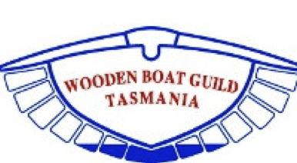

Kettering Wooden Boat Rally 8
Saturday 10 February 2024 Sunday 11 February 2024
“Be kind to each other”
Amendment 9/01/2024
Instructions for Sailing Events

- Invitation and Location
  - Kettering Yacht Club Inc (KYC) and the Wooden Boat Guild of Tasmania (WBGT) as the Organising Authority (OA) invite owners of wooden boats to enter the Kettering Wooden Boat Rally (KWBR) to be conducted on the waters of the D’Entrecasteaux Channel on Saturday 10 February 2024 and Sunday 11 February 2024.
  - The rally office and official noticeboard will be located at the KYC in Ferry Road, Kettering.

- Events and Course Area
  - The sailing events will be non-spinnaker events.
  - There will be two events for sailing yachts, the first on Saturday afternoon, and the second on Sunday afternoon.
  - The overall winners of the rally will be determined from the combination of results from both days.
  - Both events will use the be pursuit format. Each boat will be given a start time based on its estimated speed. The slowest boats will be the first to start, and the fastest boats the last to start. Placings will be determined by the order in which boats finish.
  - The start line will be from the KYC Committee Boat “Uncle Robin”, which will be moored in the D’Entrecasteaux Channel in the general vicinity of Little Oyster Cove.
  - Both events will start with a warning signal for the first start group at 13:55.
  - Both events will finish in the approximate area of the start line. See also Section 11 “Shortened Courses” below.
  - The courses to be sailed are described in the sailing instructions below.

- Communications
  - Final ‘Instructions for Sailing Events’ will be posted on the KWBR website (kwbr.org) on Thursday 9 February 2024.
  - On water communications will be via code flags on the committee boat and where possible on VHF channel 73.
  - On shore notices will be signalled by code flag L displayed at the KYC and posted on the noticeboard near the main entrance to the KYC.

- Rules
  - The Rally will be governed by the rules as defined in the 2021-2024 Racing Rules of Sailing (RRS) of World Sailing, the Australian Sailing (AS) Special Regulations Part 1 (available here), and the International Regulations for Preventing Collisions at Sea.
  - Bruny Island ferries have right of way over all yachts.
  - All boats shall comply with the prevailing Tasmanian statutory requirements, including marine and safety Tasmania requirements.
  - For protests involving an alleged breach of the rules of Part 2 of the RRS, an arbitration hearing may be held prior to a protest hearing. A boat that accepts fault at an arbitration hearing will be penalised by having its event score increased by 30% of the difference between the boat’s finishing score and the score for DSQ in its handicap Class, rounded to the nearest whole number. All other boats’ scores will remain the same. Once accepted, this decision is not subject to reopening or appeal. This alters RRS 63, 66 and Appendix A.

- Entry
  - The OA reserves the right to accept or reject any entry.
  - By lodging an entry, the entrant agrees to be bound by the rules and conditions of the Rally.

- Entry Fees
  - The entry fee for the rally includes entry for the two sailing events described in these sailing instructions.

- Responsibility
  - All those taking part in these events do so at their own risk and responsibility. The OA is not responsible for the seaworthiness of a Yacht whose entry is accepted or the sufficiency or adequacy of its equipment.
  - The OA is not responsible for any damage or injury, either on shore or at sea, either to persons or yachts, which might result from competing in these events.

- Safety
  - The attention of all persons taking part in the Rally is drawn to the requirement to be aware of the application of the Marine Safety (Misuse of Alcohol) Act 2006.
  - The Race Officer may postpone or cancel the events if the weather conditions are unsuitable. Events will be abandoned:
  - if a gale or storm warning is current for the D’Entrecasteaux Channel.
  - if a severe weather warning forecasts lightning.
  - A crew declaration shall be submitted via the KYC Crew Declaration prior to each event. Boats not complying with this shall be scored DSQ for that event. This changes RRS A5 (2021-24). A breach of this rule shall not be subject to protest by a competitor. Note: for the purposes of the rally the need for an AS Number on the Crew declaration is not required.

- Starting Procedure
  - The starting line will be laid in the general area off Kettering shown as area E the diagram below labelled “Marks A-E”.
  - The start line will be between the orange flag on the KYC committee boat “Uncle Robin” and a yellow buoy marked with the letter E (mark E in the list of courses).
  - The direction of the start will be through the start line towards the first named mark.
  - Each yacht will be assigned to a group in the range 1 to 9, with the slowest yachts in group 1, and the fastest yachts in group 9.
  - Yachts will start at 5-minute intervals as defined in RRS 26. The class flag for each group will be its applicable numeral pennant.
  - Engines can be used up to the start of a boat's preparatory signal.
  - The warning signal for each group will be the numeral pennant applicable to that group.

- Time Limit
  - Boats not finishing before 17:00 will be scored DNF.

- Shortened Courses
  - Shortened courses will be signalled by the display of flag S on the committee boat and two sounds. The Race Officer will also advise yachts of shortened courses on VHF channel 73.
  - The race officer will advise yachts if the shortened course results in a change to the finish line.

- Finishing procedure
  - The finishing line will be in the vicinity of the start line and will be crossed in the direction from the last mark.
  - The finish line will be between the blue flag on the KYC committee boat (Uncle Robin) and a turning mark (normally mark E), or an orange buoy if the course has been shortened and the finish line moved.
  - Any yacht must report its retirement as soon as practicable to the Race Officer on VHF channel 73 or by approaching the committee boat.

- Courses
  - Courses will be indicated by a code flag on the committee boat and where possible via radio on VHF channel 73.
  - If more than one lap is to be sailed, the number of laps will be indicated by a flag showing the number of laps to be sailed (2, 3, or 4).
  - The courses for both events will be chosen from the following courses:

Code | Course | Marks to:
B | Start – A – B – E – A – Finish | Starboard
C | Start – B – A – E – B – Finish | Port
D | Start – A – B – A – B – Finish | Starboard
E | Start – C – D – E – C – Finish | Starboard
F | Start – A – B – E – B – Finish | Starboard
G | Start – C – D – C – D – Finish | Starboard
H | Start – B – A – B – A – Finish | Port
J | Start – D – C – E – C – Finish | Port
Q | Start – A – C – D – Finish | Starboard
R | Start – A – D – C - Finish | Port
V | Start – A – B – C – D – Finish | Starboard
W | Start – D – C – B – A – Finish | Port

- Marks
  - The locations of turning marks are described below and shown on the diagram below labelled “Marks A-E”.
  - Marks A, B, C and D are orange permanent marks. Mark E is both one end of the starting line and a turning mark.

A | 0.25 nm southwest of Simmonds Point
B | 0.3 nm southeast of Speculator point
C | 0.3 nm north of Kinghorne Point
D | 0.25 nm south of Helliwells Point
E | An inflatable yellow buoy marked with the letter E

- Protests and Requests for Redress
  - Protest/redress forms are available at the rally office. Protests and requests for redress shall be delivered there within the specified time limit.
  - The protest time limit is sixty minutes after the last boat has finished racing.
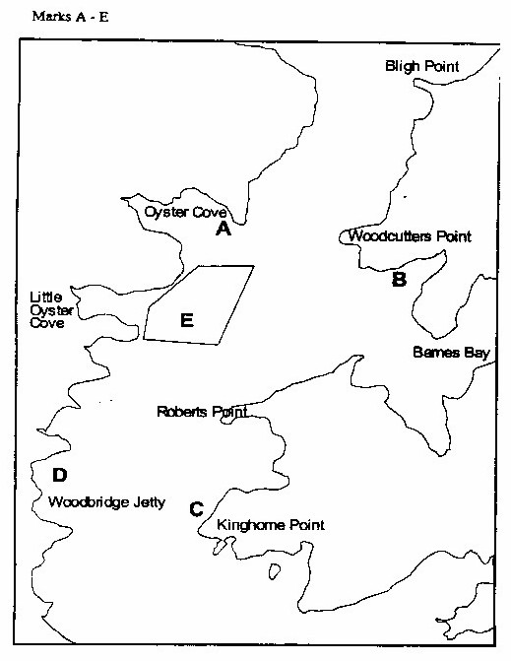
  - A committee nominated by the OA will hear the protest or request for redress as soon as possible.

