Amended 10 /01/2024

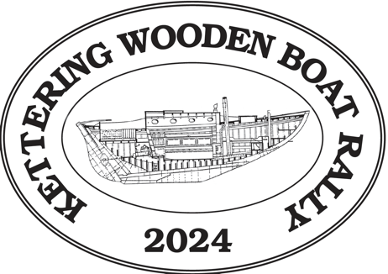

Kettering Wooden Boat Rally 8
Saturday 10 February 2024 Sunday 11 February 2024

Small Boats Instructions and Information

- Tides
Saturday 10 February 2024
High tide about 8.28am
+/- 1.59m
Low tide about 4.11pm
+/- 0.20m

Sunday 11 February 2024
High tide about 9.28am
+/- 1.53m
Low tide about 5.00pm
+/- 0.24m

- Event program
2.1 Saturday
Small Boats launch at Trial Bay in time to get to the sailpast.
Launch 10am – 10.30am

Before launching, register by SMS to Trip Leader John Pretty on 0406 735 236.

The sailpast will take place at approximately 12 Noon off Kettering Point.
The sailpast vessel is Goondooloo.

After the sailpast, small boats have the option of cruising a marked course from Kettering Point to the KYC orange permanent mark situated about 0.3m north of Kinghorne Point (mark C), then to the KYC orange permanent mark situated about 0.25M south of Helliwells Point (mark D), then back to the Trial Bay boat ramp. (This course is about 5-6 nm)

Lunch can be taken on board while cruising or back at Trial Bay for the faster boats.

Small boats choosing not to sail this course may enjoy themselves in the vicinity of Trial Bay.

All boats must register their return by SMS to John Pretty on the above number.

2.2 Sunday
Launch 10am -10.30am at Trial Bay.

Before launching, register by SMS to Trip Leader John Pretty on 0406 735 236.

Small boats have the option of cruising a triangular course from a mark outside Trial Bay then to a mark off the southern point of Perch Bay, then a mark at the head of Perch Bay then back to Trial Bay. (This course is about 2 nm)

All boats must register their return by SMS to John Pretty on the above number.

2.3 On-shore
Boats on trailers may overnight in the car park outside the entrance to the Oyster Cove Marina. Alternatively small boats may berth overnight in the waters adjacent to the KYC club house.

Friday night tba

Saturday night
Join all the participants in the Rally at the KYC club house from 17.30 hours where food trucks and the KYC bar will cater for food and drinks.

Sunday night
As for Saturday night evening eats and drinks, draws for prizes and conclusion of the rally.

- Safety
3.1 There will be two “Mother Duck” boats to accompany the small boats but it is expected that participants will exercise proper caution with regard to their own safety, boat capabilities and prevailing conditions.

3.2 Wearing of Life Jackets is compulsory for participants, and other applicable MAST requirements for small boats are to be adhered to.

3.3 Bad weather.
A decision will be made on each day whether to proceed or to amend the courses to be sailed.

- Communications
4.1 Final ‘Instructions for Small Boat Events’ will be posted on the KWBR website (kwbr.org) on Thursday 9 February 2024.
4.2 On water communications will be via VHF channel 73. (Note The KWBR sailing events are also on channel 73).
4.3 A copy of the instructions will be included in the boat bag for each registered boat available from the KYC Ferry Road Kettering from Friday 9 February 2024 (times to be advised).

- KYC permanent marks

C | 0.3 nm north of Kinghorne Point
D | 0.25 nm south of Helliwells Point

